**CABINET KNOBS**

We are delighted to introduce you to our exquisite collection of [cabinet knobs](https://trilliumnow.com/collections/cabinet-knobs). The significant impact on the overall aesthetics of your living space. With our meticulously curated selection of cabinet handles, we aim to offer not just functional hardware, but pieces of art that elevate the ambiance of your home.

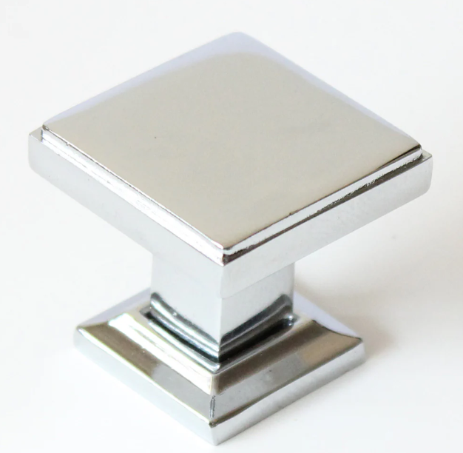

****Craftsmanship and Quality:****

Each knob in our collection is crafted with precision and care, utilizing only the finest materials to ensure durability and longevity. Whether you prefer the classic charm of brass, the sleek elegance of stainless steel, or the rustic allure of bronze, we have an array of finishes to suit every taste and style.

**Versatility and Design:**

Our collection boasts a diverse range of designs, from minimalist modern to intricately detailed traditional styles. Whether you're updating your kitchen [cabinets](https://trilliumnow.com/collections/cabinet-knobs), refurbishing an antique dresser, or adding a touch of sophistication to your bathroom vanity, our versatile selection ensures that you'll find the perfect knobs to complement your decor.

**Functionality and Ergonomics:**

Beyond their aesthetic appeal, our [cabinet knobs](https://trilliumnow.com/collections/cabinet-knobs) are designed with functionality in mind. Each knob is ergonomically shaped for comfortable grip and ease of use, allowing you to effortlessly open and close your cabinets with a simple twist of the wrist. Additionally, our knobs are built to withstand daily wear and tear, ensuring smooth operation for years to come.

**Personalization and Customization:**

We understand that every home is unique, which is why we offer customization options to help you create a truly personalized look. Whether you're seeking custom finishes, bespoke designs, or specialized sizes, our team is dedicated to bringing your vision to life. With our commitment to quality craftsmanship and attention to detail, you can trust that your customized knobs will exceed your expectations.

**Environmental Responsibility:**

We are committed to sustainability and environmental responsibility. That's why we prioritize eco-friendly materials and manufacturing processes throughout our production chain. From sourcing recycled metals to minimizing waste in our facilities, we strive to reduce our environmental footprint and contribute to a healthier planet for future generations.

**Customer Satisfaction Guarantee:**

Your satisfaction is our top priority. We stand behind the quality of our products and are confident that you'll love the elegance and functionality of our [cabinet knobs.](https://trilliumnow.com/collections/cabinet-knobs) However, if for any reason you're not completely satisfied with your purchase, please don't hesitate to contact us. Our dedicated customer service team is here to assist you and ensure that your experience with us is nothing short of exceptional.